

Draw It or Lose It – Web-Based Game Application

CS 230 Project Software Design Proposal
Version 2.5

Table of Contents

CS 230 Project Software Design Template 1
Table of Contents 2
Document Revision History 2
Executive Summary 3
Requirements 3
Design Constraints 3
System Architecture View 3
Domain Model 3
Evaluation 4
Recommendations 5

Document Revision History

Version | Date | Author | Comments
1.0 | 06/25/26 | Nikita Simon | Initial software design document for The Gaming Room application.

Executive Summary

The Gaming Room intends to expand its Android-based game, Draw It or Lose It, into a web-based application capable of supporting multiple operating systems and devices through a single software solution. The new application must maintain consistent gameplay across platforms while making sure that game, team, and player names remain unique and that only one instance of the game service exists in memory at any given time.

This design proposes a Java-based distributed application that employs established object-oriented design patterns to improve maintainability, scalability, and reliability. By implementing the renowned Singleton pattern for the game service and the Iterator pattern for searching existing game objects, the proposed architecture satisfies the client's functional requirements while providing a flexible foundation for future expansion.

Requirements

Business Requirements

- Expand Draw It or Lose It beyond Android to a web-based application.
- Support users on multiple operating systems and devices.
- Maintain consistent, undisturbed gameplay regardless of platform.
- Ensure every game, team, and player has a unique name.
- Allow multiple games to operate simultaneously.

Technical Requirements

- Develop the application using Java.
- Implement the Singleton design pattern to establish a single GameService instance.
- Use the Iterator pattern when browsing collections of games, teams, and players.
- Assign unique identifiers to every game, team, and player.
- Design the application using object-oriented principles for future scalability and maintenance.

Design Constraints

The application must ideally operate as a distributed web-based system capable of supporting clients on Windows, macOS, Linux, and mobile devices without requiring platform-specific implementations. Consequently, the software should rely on Java's platform independence and avoid dependencies on operating-system-specific functionality.

The client requires that every game, team, and player possesses a unique identifier and name. This constraint necessitates implementing validation logic before new objects are created and maintaining centralized and stern control of identifier generation through a singleton service. Without these safeguards, duplicate objects could compromise application integrity.

The software must also remain scalable and maintainable as upcoming features are introduced. To satisfy this requirement, the application should follow object-oriented principles including inheritance, encapsulation, and abstraction while employing recognised software design patterns such as Singleton and Iterator. These patterns reduce code duplication, introduce predictability, simplify maintenance, and improve long-term extensibility.

System Architecture View

Please note: There is nothing required here for these projects, but this section serves as a reminder that describing the system and subsystem architecture present in the application, including physical components or tiers, may be required for other projects. A logical topology of the communication and storage aspects is also necessary to understand the overall architecture and should be provided.

Domain Model

The UML class diagram showcases the domain model for the Draw It or Lose It application by defining the primary entities involved in gameplay and the relationships between them. At the centre of the design is the Entity base class, which encapsulates the common attributes shared by all game objects, namely a unique identifier (id) and a unique name (name). Rather than duplicating these properties across multiple classes, the Game, Team, and Player classes inherit from Entity, promoting code reuse and simplifying future maintenance.

The GameService class functions as the central controller responsible for creating, storing, and managing game instances. It applies the Singleton design pattern to ensure that only one instance of the service exists throughout the application's lifetime, allowing identifiers to be generated consistently and preventing duplicate or simultaneous game service objects. GameService maintains a collection of Game objects, while each Game contains zero or more Team objects, and each Team contains zero or more Player objects. This hierarchical relationship accurately models the real-world structure of the game, where a single game may consist of multiple teams and each team may contain multiple players.

Several object-oriented programming principles are depicted realistically throughout the design. Inheritance is achieved through the Entity base class, allowing common attributes and behaviours to be shared among Game, Team, and Player. Encapsulation is painstakingly maintained by keeping object data private while exposing controlled access through constructors and accessor methods. Abstraction simplifies the overall design by separating shared functionality from specialised behaviour, enabling each class to focus on its individual responsibility. The design also incorporates recognised software design patterns. The Singleton pattern guarantees a single GameService instance, while the Iterator pattern is used when searching collections to ensure that game, team, and player names remain unique before new objects are created. Together, these principles and patterns produce a scalable, maintainable, and efficient architecture that satisfies the client's requirement for a distributed, multi-platform game application.
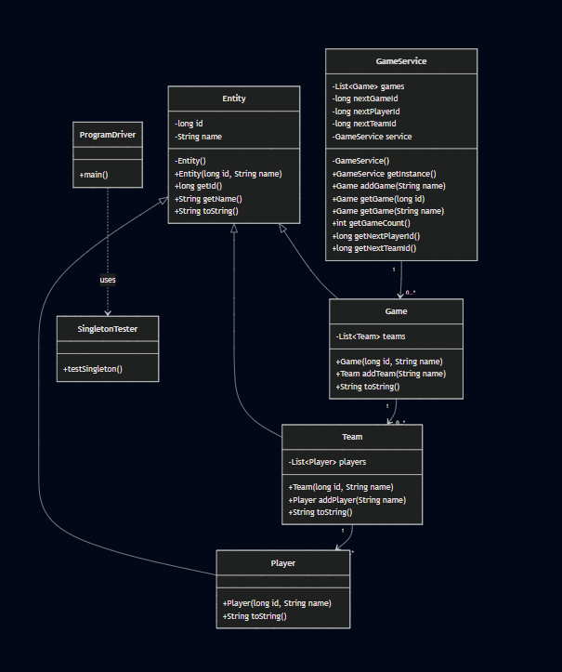



Evaluation (next page)

Evalution | Mac | Linux | Windows | Mobile Devices
Server-Side Requirements | macOS offers server capabilities, though it is not commonly selected for enterprise web hosting. Apple's hardware restrictions and limited server ecosystem make it less practical for large-scale deployment. Whilst macOS provides excellent stability and security, it is generally better suited for software development than production server environments. | Linux is the preferred operating system for hosting modern web applications because it provides exceptional stability, reliability, security, and scalability. Most cloud providers and enterprise data centres rely on Linux due to its open-source nature, minimal licensing costs, and strong support for Java web applications, Apache, Nginx, and container technologies such as Docker and Kubernetes. | Windows Server provides a mature environment for hosting web applications and supports a broad range of enterprise software. Its graphical administration tools make server management accessible, although licensing costs can become expensive as deployment scales. Windows is suitable for organisations already invested in Microsoft's ecosystem but may not provide the same cost-effectiveness as Linux for large-scale cloud hosting. | Mobile operating systems are not designed to host web servers for enterprise applications. Instead, Android and iOS function exclusively as client platforms that communicate with the server through secure RESTful APIs over HTTPS.
Client-Side Requirements | Safari serves as the primary browser on macOS whilst remaining fully compatible with modern web technologies. Responsive interfaces and cross-browser testing ensure consistent experience alongside Windows and Linux users. | Linux users have access to browsers such as Firefox and Chrome that fully support HTML5, CSS3, and JavaScript. Standards-based web development ensures compatibility without requiring operating-system-specific modifications. | Modern browsers such as Microsoft Edge, Google Chrome, Mozilla Firefox, and Opera provide exceptional compatibility for responsive HTML5 web applications. Development should follow recognised web standards to ensure consistent experience across browsers. | Responsive web technologies allow Android and iOS devices to access the application through their browsers without requiring separate native applications. This approach largely reduces development costs whilst maintaining consistent functionality across smartphones and tablets.
Development Tools | macOS supports the same Java development ecosystem whilst additionally offering Xcode for Apple-specific development. Developers targeting Apple devices may require access to macOS hardware and an Apple Developer account. | Linux supports nearly all modern open-source development tools, including Eclipse, IntelliJ IDEA, VS Code, Git, Maven, Gradle, Docker, and Kubernetes. Most tools are freely available, making Linux highly attractive for development teams seeking to minimise licensing costs. | Windows supports a wide selection of development tools, including Eclipse, IntelliJ IDEA, Visual Studio Code, Git, Maven, and Java Development Kit (JDK). Some commercial tools require licensing, whilst many open-source alternatives remain freely available. | Mobile platforms require responsive web design frameworks, browser testing tools, and device emulators to ensure compatibility across different screen sizes and operating system versions. Supporting multiple platforms increases testing requirements but avoids maintaining separate native codebases when using browser-based deployment.

Recommendations

Operating Platform

Following an evaluation of the available operating platforms, Linux is the recommended server operating system for hosting The Gaming Room's Draw It or Lose It application. Linux provides exceptional reliability, scalability, performance, and security whilst eliminating recurring server licensing costs associated with proprietary operating systems. Because the application is expected to support thousands of concurrent players across numerous operating systems, Linux's widespread adoption within enterprise data centres and cloud computing environments makes it reliably well suited to this deployment. Its compatibility with Java, Apache, Nginx, Docker, Kubernetes, and major cloud providers further strengthens its suitability for a distributed web-based architecture.

Operating Systems Architectures

Linux employs a modular monolithic kernel architecture that balances performance with flexibility. Core operating system services operate within kernel space to maximise execution speed, whilst user applications execute within protected user space to improve stability and security. Multi-user capabilities, productive process scheduling, virtual memory management, and comprehensive networking support enable Linux to handle large numbers of simultaneous client connections with minimal overhead. These architectural characteristics make Linux noticeably well suitable for hosting a high-availability web application such as Draw It or Lose It.

Storage Management

The recommended storage solution combines a relational database management system with cloud-based object storage. Structured application data including user accounts, authentication credentials, player statistics, teams, games, and configuration information, should be maintained within a relational database such as PostgreSQL or MySQL. Meanwhile, the application's extensive image library should be stored separately using scalable cloud object storage or a content delivery network (CDN). Separating structured data from static image assets reduces server workload, improves retrieval performance, simplifies backup procedures, and allows storage capacity to expand alongside future application growth.

Memory Management

Clever memory management is top priority because Draw It or Lose It progressively renders high-definition images whilst supporting numerous concurrent game sessions. Rather than loading the complete image library into memory, the application should utilise lazy loading techniques to retrieve image assets only when required. Frequently accessed images may be temporarily cached to reduce repeated disk access, whilst completed game sessions should straightaway release unused resources through Java's automatic garbage collection. This strategy minimises memory consumption, improves application responsiveness, and enables the server to accommodate substantially more simultaneous players without performance degradation.

Distributed Systems and Networks

The recommended architecture follows a distributed client-server model in which Linux hosts the central application server whilst desktop and mobile clients communicate through secure RESTful APIs over HTTPS. This architecture enables Windows, macOS, Linux, Android, and iOS devices to interact with the same backend services using standard web technologies. Network reliability can be improved through redundant servers, cloud load balancing, automated failover mechanisms, and routine data replication. These techniques reduce downtime whilst ensuring that individual component failures do not interrupt gameplay. Because each client communicates independently with the central server, updates can be deployed once without requiring modifications to every supported platform.

Security

Protecting user information remains one of the client's highest priorities. All communication between clients and servers should therefore utilise HTTPS with Transport Layer Security (TLS) encryption to prevent unauthorised interception of sensitive information. User credentials should be protected using salted password hashing algorithms rather than plain-text storage, whilst role-based authorisation ensures users may access only those resources appropriate to their permissions. Regular dependency updates, comprehensive input validation, secure session management, logging, monitoring, and routine vulnerability assessments should form part of the application's ongoing security strategy. Linux further strengthens the security posture through its mature permissions model, process isolation, firewall capabilities, and frequent security updates, making it an ideal platform for protecting user data across multiple operating systems.

Final Recommendation

Point to be noted at last, Linux provides the strongest foundation for The Gaming Room's expansion into a distributed, multi-platform environment. When combined with Java, RESTful APIs, responsive web technologies, relational database management, cloud-based storage, smart memory management, and layered security practices, the proposed architecture delivers a highly scalable, maintainable, and secure solution capable of supporting future growth whilst providing a consistent experience for users across Windows, macOS, Linux, Android, and iOS devices.

